**A**

**Synopsis**

**On**

**Visualizing and Forecasting Stocks Using Dash**

**Submitted By-:**

**Group. No.**

**Sanya Rastogi - 2100290140116**

**Akshi Vishnoi - 2100290140018**

**Ayush Pathak – 2100290140046**

**Ayush Jha - 2100290140045**



**Under The Supervision Of -:**

**Mr. Ankit Verma**

**Department of Computer Application,**

**KIET Group of Institutions,**

**Delhi-NCR, Ghaziabad**

**10 September, 2022**

**ABSTRACT**

We will be creating a single-page web application using Dash (a python framework) and some machine learning models which will show company information such as logo, registered name and description and also the stock plots based on the stock code given by the user. Also the ML model will enable the user to get predicted stock prices for the date inputted by the user.

This volatility of stock makes investors nervous while investing in a company. So to understand the risk associated with it there must be a proper analysis of stock before buying it.

Developing this simple project idea using the Dash library (of Python), we can make dynamic plots of the financial data of a specific company by using the tabular data provided by yfinance (yahoo) python library. On top of it we can use a machine learning algorithm to predict the upcoming stock prices.

**Table of Contents**

1. Introduction
2. Technologies / Software Requirements
3. Hardware requirement / Hardware Used
4. Modules Description
5. Outputs
6. Conclusion
7. Gantt Chart (In terms of weeks)

**Introduction**

Stock investments provide one of the highest returns in the market. Even though they are volatile in nature, one can visualize share prices and other statistical factors which helps the keen investors carefully decide on which company they want to spend their earnings on.

Developing this simple project idea using the Dash library (of Python), we can make dynamic plots of the financial data of a specific company by using the tabular data provided by yfinance python library. On top of it, we can use a machine learning algorithm to predict the upcoming stock prices.

**Technologies / Software Requirements**

We will be using the Python (Jupyter Notebook) with :

* **Dash** framework,
* Various libraries such as:
* **yfinance** is a library that allows us to fetch financial data of a company from its stock code directly.
* **gunicorn** and **lxml** libraries will be used for the application's deployment i.e. to host the app on a target server.
* **plotly** library of Python is used to generate plots of data.
* **numpy** library is used for multi-dimensional array operations
* **pandas** is used for creating DataFrames to efficiently manage the data.
* **Heroku** is a platform as a service (PaaS) that enables developers to build, run, and operate applications entirely in the cloud.

**Hardware requirement / Hardware Used**

* RAM of minimum 4 GB recommended or above
* Hard disk with minimum storage of 10 GB or above
* Processor - i5, 3rd generation or above

**Modules Description**

1. **Developing and designing web page**

We will be designing the basic layout of the web application with the help of dash.The web layout using Dash HTML Components and Dash Core Components.In this two divisions are used to develop the layout-:the first one is for our inputs like stock code, date range selector, number of days of forecast and buttons. The second division will be for the data plots and company's basic information (name, logo, introduction) only.

1. **Retrieving data set and plotting graph**

We are going to use the yfinance python library to get company information (name, logo and description) and stock price history. Dash's callback functions will be used to trigger updates based on change in inputs. The plots of data will be generated with the help of plotly library.

1. **Implementing ML model to retrieve information**

Machine learning model i.e.; **Support Vector Regression** will be built for predicting the stock prizes. Dataset for the last 60 days will be fetched and divided into 9:1 for training and testing. **SVR** model will be trained with the training dataset.

1. **Testing the developed web application**

For testing the SVR model’s performance we will use metrics such as Mean Squared Error (MSE) and Mean Absolute Error (MAE) on the testing dataset.

1. **Deploying the project on Heroku**

Heroku is a cloud based Platform as a Service (PaaS). Developers use Heroku to deploy, manage, and scale modern apps. Our platform is elegant, flexible, and easy to use, offering developers the simplest path to getting their apps to market. We will deploy our project on Heroku once it is completed.

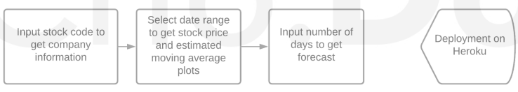

**Output**

After finishing all the modules and tasks, we should have a complete project where user input - stock, code can give us the company information and relevant plots. Also, user input number of days can give us a forecast plot. Finally, our web app will be deployed and can be accessed by anyone in the world.

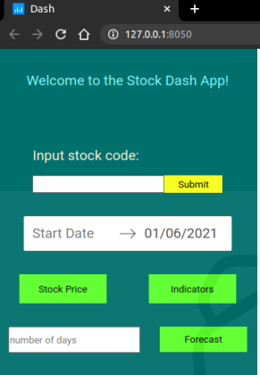

**Conclusion**

Stock market Trading is the most sought after and so its popularity is increasing and researchers ought to find new techniques for prediction. Stock forecasting and visualizing techniques help investors and individuals to handle the stock market. For predicting the stock prices correctly the forecasting model should have great precision. The scope of visualizing and forecasting stock has a very huge in the field of stock market. According to a recent report the number of investors investing in the stock market is increasing every year, therefore a system of visualizing and forecasting stocks is required to guide the investors to invest carefully in the stocks.

**Gantt Chart**

